Ayush Goyal
190905522 CSE D Roll 62

Operating Systems Lab 3: Processes and Signals

1. Write a C program to block a parent process until the child completes using a wait system call.

Code:

#include<unistd.h>
#include<sys/types.h>
#include<sys/wait.h>
#include<stdio.h>
#include<string.h>
#include<stdlib.h>

int main(){
pid_t pid;
int status;
pid = fork();
switch(pid){
case -1: printf("Error occured!...\n");
exit(-1);
case 0: printf("Executing child process...\nNow, Exiting child process...\n");
exit(0);
default: wait(&status);
printf("Executing parent process...\nChild Status has returned: %d\nNow, Exiting parent process...\n", status);
}
return 0;
}

Output:

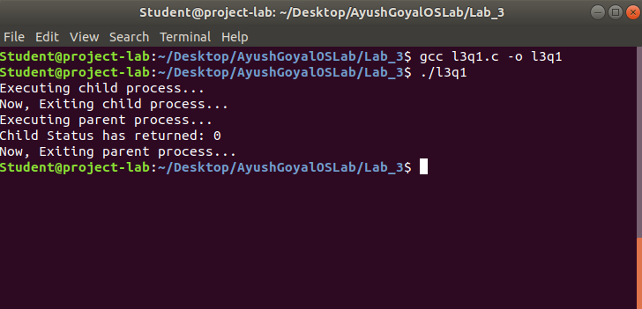
2. Write a C program to load the binary executable of the previous program in a child process using the exec system call.

Code:

#include<unistd.h>
#include<sys/types.h>
#include<sys/wait.h>
#include<stdio.h>
#include<string.h>
#include<stdlib.h>

int main(){
pid_t pid;
int status;
pid = fork();
switch(pid){
case -1: printf("Error occured!...\n");
exit(-1);
case 0: printf("Executing child process of main program.\n");
printf("______\n");
execlp("./l3q1", "l3q1", NULL);
exit(0);
default: wait(&status);
printf("______\nExecuting parent process of main program.\nChild Status has returned: %d\nNow, Exiting parent process of main program...\n", status);

}
}

Output:

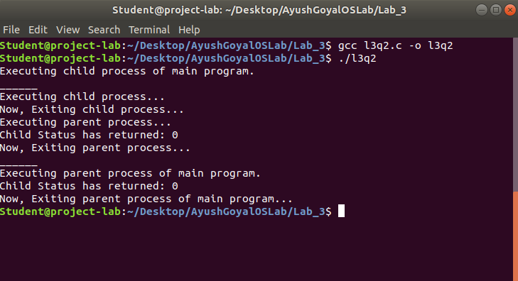
3. Write a program to create a child process. Display the process IDs of the process, parent and child(if any) in both the parent and child processes.

Code:

#include<unistd.h>
#include<sys/types.h>
#include<sys/wait.h>
#include<stdio.h>
#include<string.h>
#include<stdlib.h>

int main(){
pid_t pid;
int status;
pid = fork();
switch(pid){
case -1: printf("Error occured!...\n");
exit(-1);
case 0: printf("Executing child process...\nProcess ID: %d\nParent Process ID: %d\nChild Process ID: %d\nNow, Exiting child process...\n", getpid(), getppid(), pid);
exit(0);
default: wait(&status);
printf("Executing parent process...\nChild Status has returned: %d\nProcess ID: %d\nParent Process ID: %d\nChild Process ID: %d\nNow, Exiting parent process...\n", status, getpid(), getppid(), pid);
}
return 0;
}

Output:

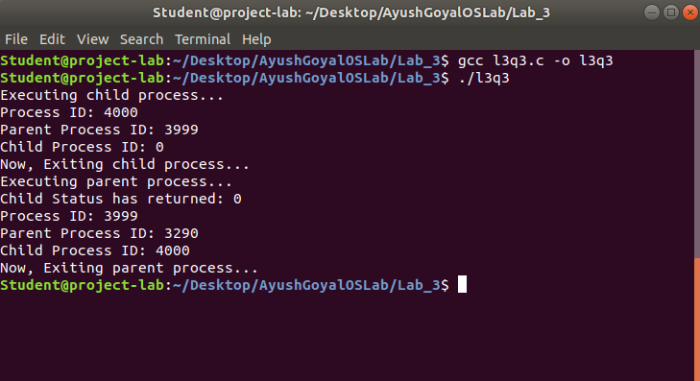
4. Create a zombie(defunct) child process(a child with exit() call, but no corresponding wait() in the sleeping parent) and allow the init process to adopt it(after parent terminates). Run the process as a background process and run the “ps” command.

Code:

#include<unistd.h>
#include<sys/types.h>
#include<sys/wait.h>
#include<stdio.h>
#include<string.h>
#include<stdlib.h>

int main(){
pid_t pid;
int status;
pid = fork();
switch(pid){
case -1: printf("Error occured!...\n");
exit(-1);
case 0: printf("Executing child process...\nNow, Exiting child process...\n");
exit(0);
default: sleep(5);
printf("Executing parent process...\nChild Status has returned: %d\nNow, Exiting parent process...\n", status);
}
return 0;
}
Output:
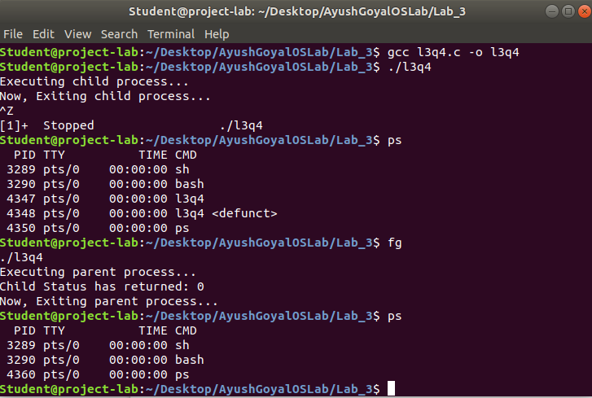
THE END

